Exp 1: Simulation of FDMA in MATLAB

Objective 1:

Code:

clc;
clear;
close all;

fs = 1000;

t = 0:1/fs:1;

TBW = 600;

Users = 3;

CBW = TBW / Users;

fc = [100 300 500];

m = sin(2*pi*10*t);

s1 = m .* cos(2*pi*fc(1)*t);

s2 = m .* cos(2*pi*fc(2)*t);

s3 = m .* cos(2*pi*fc(3)*t);

figure;

subplot(2,1,1);

plot(t, s1, 'r', t, s2, 'g', t, s3, 'b');

grid on;

title('FDMA Channel Allocation');

xlabel('Time (s)');

ylabel('Amplitude');

legend('User 1', 'User 2', 'User 3');

subplot(2,1,2);

bar(1:Users, CBW * ones(1, Users));

grid on;

xlabel('Users');

ylabel('Channel Bandwidth (kHz)');

title('Channel Bandwidth per User');

Output :

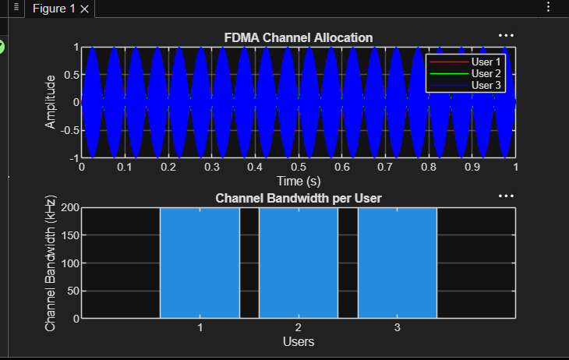

Objective 2:

Code:

clc;
clear;
close all;
BW = 200;
Users = 3;
M = 2;
DataRate = BW * log2(M);
Rate = DataRate * ones(1, Users);
disp(' User Data Rate (kbps)');
disp([(1:Users)' Rate']);
figure;
bar(1:Users, Rate);
xlabel('Users');
ylabel('Data Rate (kbps)');
title('FDMA Data Rate for Each User');
grid on;

Output:

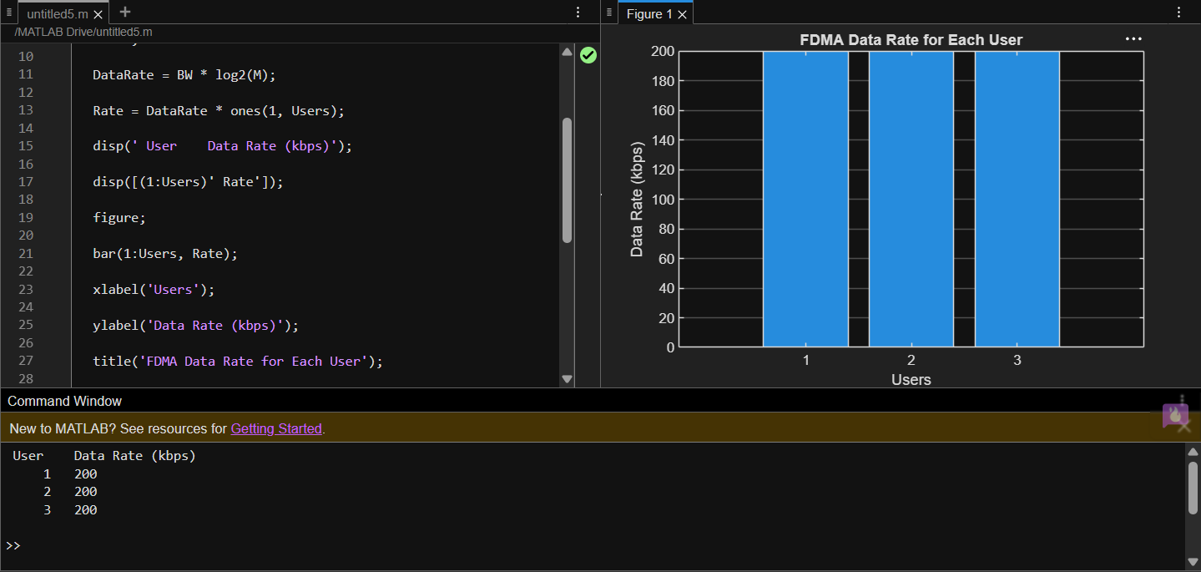

Objective 3:

Code :

clc;
clear;
close all;

Ps = 1;

Pn = [0.1 0.05 0.01];

Users = 1:3;

SNR = 10 * log10(Ps ./ Pn);

disp('User Noise Power(W) SNR(dB)');

disp([Users' Pn' SNR']);

figure;

bar(Users, SNR);

xlabel('Users');

ylabel('SNR (dB)');

title('Signal-to-Noise Ratio of FDMA Users');

grid on;

output :

